C7_1

setwd(".")  
library(knitr)

Apartado A

x<-seq(5,7,0.01)  
s1<-1.1  
s2<-0.9  
n1<-100  
n2<-200  
Alfa<-0.02  
DPx<-dnorm(x,6,sqrt((s1^2/n1)+(s2^2/n2)))  
plot(x,DPx,type="l",col="black", lwd=2,ylab="Densidad de Probabilidad",xlab="Diferencia de Medias")  
grid()  
dcha<-(Alfa/2)  
xliminf<-qnorm(dcha,6,sqrt((s1^2/n1)+(s2^2/n2)))  
izqda<-(1-Alfa/2)  
xlimsup<-qnorm(izqda,6,sqrt((s1^2/n1)+(s2^2/n2)))  
xv<-x[x>=xliminf & x <=xlimsup]  
yv<-DPx[x>=xliminf & x <=xlimsup]  
  
xv<-c(xv,xlimsup,xliminf)  
yv<-c(yv,DPx[1],DPx[1])  
polygon(xv,yv,col="grey",density=25,border="brown")  
abline(v=xliminf, col="red")  
abline(v=xlimsup, col="red")

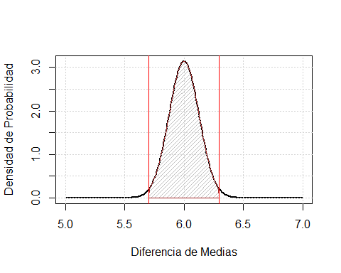

xliminf

## [1] 5.704362

xlimsup

## [1] 6.295638

Conclusiones